**DAILY ONLINE ACTIVITIES SUMMARY**

|  |  |  |  |  |  |  |  |  |
| --- | --- | --- | --- | --- | --- | --- | --- | --- |
| **Date:** | **30-05-2020** | | | | | **Name:** | **Nihal Rafiq** | |
| **Sem & Sec** | **4th A** | | | | | **USN:** | **4AL18CS052** | |
| **Online Test Summary** | | | | | | | | |
| **Subject** | | **1. Data Communication**  **2. Complex Analysis, Probability and Statistical Method** | | | | | | |
| **Max. Marks** | | **1. 30**  **2. 30** | | **Score** | | | **1. 28**  **2. 28** | |
| **Certification Course Summary** | | | | | | | | |
| **Course** | **Introduction to R** | | | | | | | |
| **Certificate Provider** | | | **Great Learning Academy** | | **Duration** | | | **2.5 hours** |
| **Coding Challenges** | | | | | | | | |
| **Problem Statement: 1. Write a C program to count Uppercase, Lowercase, special characters and numeric values for a given String.** | | | | | | | | |
| **Status: Executed** | | | | | | | | |
| **Uploaded the report in Github** | | | | | **Yes** | | | |
| **If yes Repository name** | | | | | **https://github.com/nihal-art/lockdown-coding** | | | |
| **Uploaded the report in slack** | | | | | **Yes** | | | |

Online Test Details:

1. The test was from 3rd and 4th module of DATA COMMUNICATION (18CS46).The time duration was 40 minutes from 09.15 am to 10.00 am. There were 30 questions of MCQ type. Score I received is 28/30.

2. The test was from 3rd module of COMPLEX ANALYSIS, PROBABILITY AND STATISTICAL METHOD. The duration of the test was 40minutes from 03.00pm to 03.40pm.There were two rounds in online test. First round of 10 MCQ of 1 marks each and second round was 10 MCQ of 2marks each.

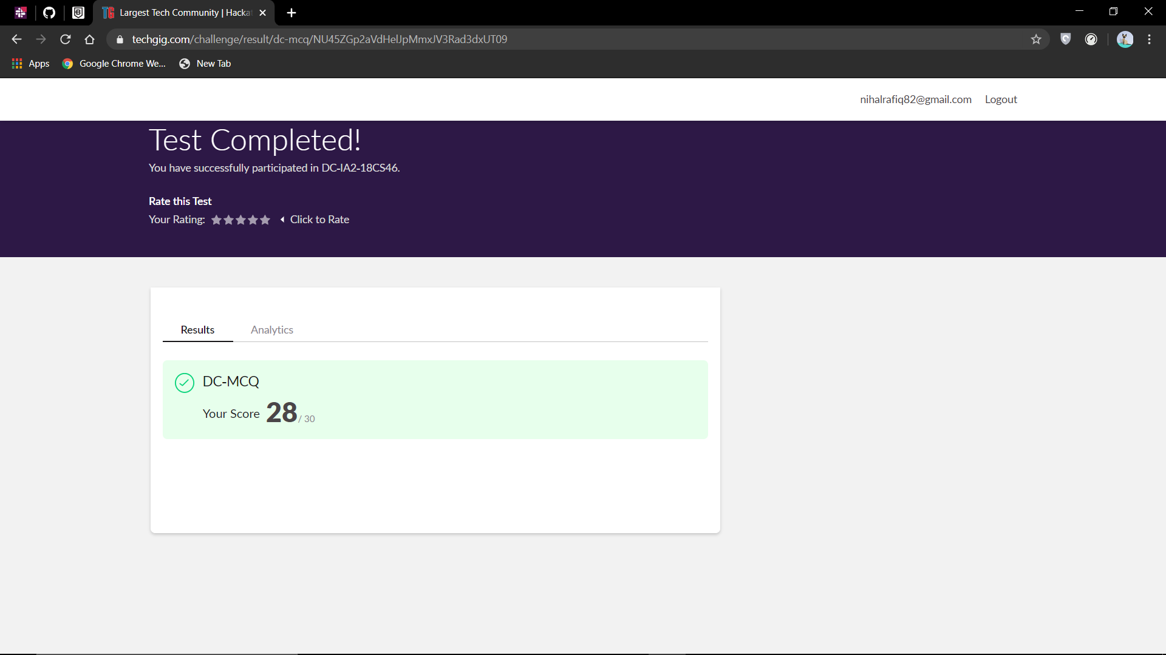

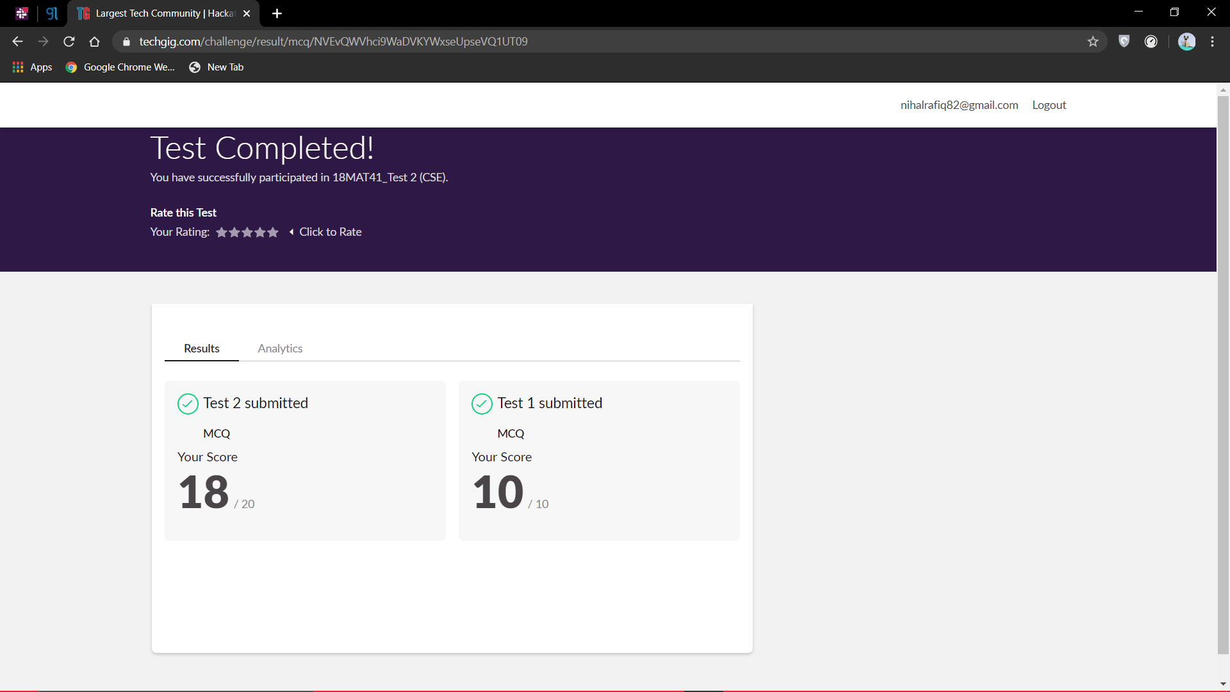

Certification Course Details:

I have opted introduction to R certification course.

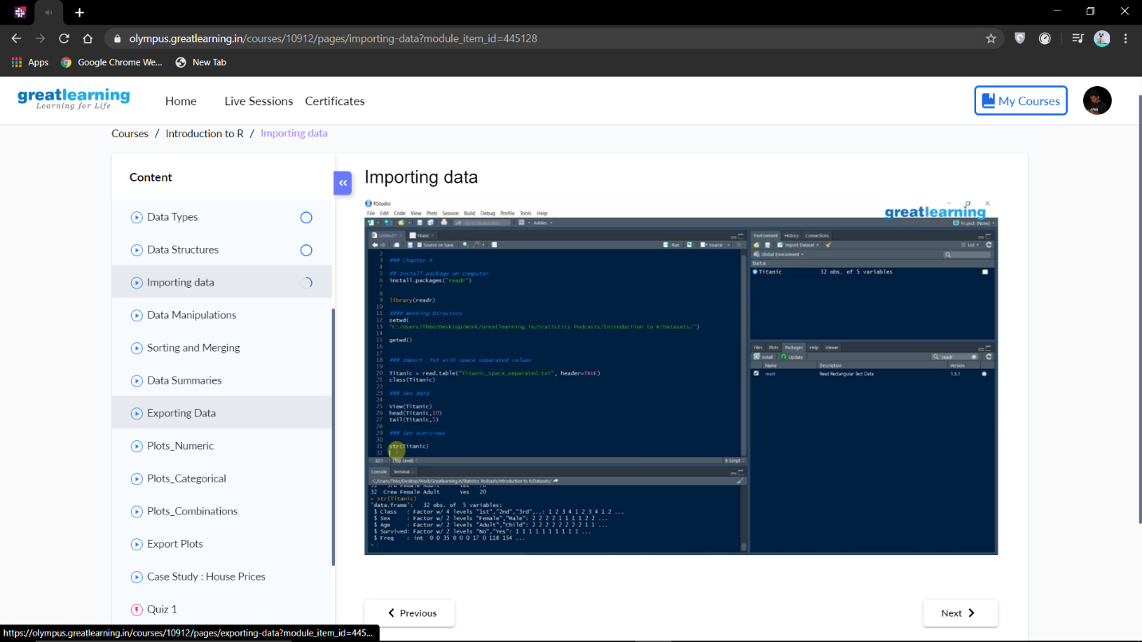

Coding Challenges Details:

**CODING CHALLENGES:**

1. Write a C program to count Uppercase, Lowercase, special characters and numeric values for a given String.

Input: Read a String (combination of character, numeric, special character) from keyboard. Ex: #HaaGs01fOr@haaks07 Output: Upper case letters: 5, Lower case letters : 8, Numbers : 4,Special Characters : 2

